**Electronic Signature Option - Information for Schools**

Beginning in the 2017-2018 school year, parents have the option to electronically sign certain forms instead of submitting signed paper copies to their child’s school.

Parents will have the option of electronically signing the following forms:

* Media Release Form
* Network/Internet Acceptable Use Agreement
* Directory Information Opt-Out Letter
* Parent and Student Acknowledgement of Student Code of Conduct

Parents will be able to access and submit these forms through our Student Reservation System (SRS). The new process for electronic forms will be available to parents as of Aug 1, 2017.

As parents complete the electronic forms, schools will be able to monitor submissions. A report is available that provides details of all electronically signed forms that have been submitted. This report includes student and parent information and the date of submission. The report, named *“Electronically Signed PCS Student Forms,”* is accessible in the Reporting Services system in the Student Data folder. *Screenshot below:*

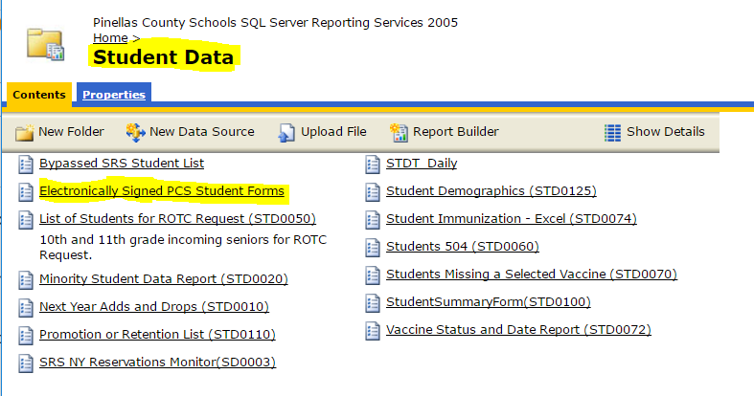

All electronically submitted forms can also be accessed within the individual student’s record in Focus. A tab labeled *PCS Student Forms* will contain a (Yes/No) indicator identifying which forms have been submitted with a PDF copy available to view or print. *Screenshot below:*

